Physics 30 1996 June
Use the following information to answer the next five questions.

Deployment of Air Bags

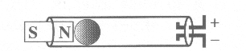

Air bags are designed to deploy when a car, moving at a minimum speed of 18 km/h, comes to a crashing stop. The impact sensor, also moving at 18 km/h, consists of a small steel ball of 0.050 kg, which is held in position by a magnet, as shown above. On impact, the ball breaks free in 1.00 x 10⁻³ s and slides within a cylinder. The ball makes contact with two electrodes at the end of the cylinder, thus activating the air bag.

- What is the magnitude of the force required to break away from the magnet?
A. 2.5 x 10⁵ N
B. 1.3 x 10⁵ N
C. 2.5 x 10² N
D. 1.3 x 10² N

- If the car was moving at 18 km/h, the maximum speed of the ball immediately after impact would be
A. 62 m/s
B. 18 m/s
C. 5.0 m/s
D. 0 m/s

- When the ball makes contact with the electrodes at the end of the cylinder, the ball behaves like a
A. circuit
B. switch
C. resistance
D. energy source

- If the car was initially moving at 18 km/h, the driver had a mass of 70 kg, and the air bag stopped him in 0.10 s, the magnitude of the force acting on the driver during the deceleration would be
A. 1.3 x 10⁴ N
B. 3.5 x 10³ N
C. 1.3 x 10³ N
D. 3.5 x 10² N

- The entire process, from impact to air bag inflation, takes less than 3.0 x 10⁻³ s. During this same time, how far forward would a passenger who was not wearing a seat belt move?
A. 1.5 x 10⁻² m
B. 1.8 x 10⁻² m
C. 5.0 m
D. 0 m

Use the following information to answer the next six questions.
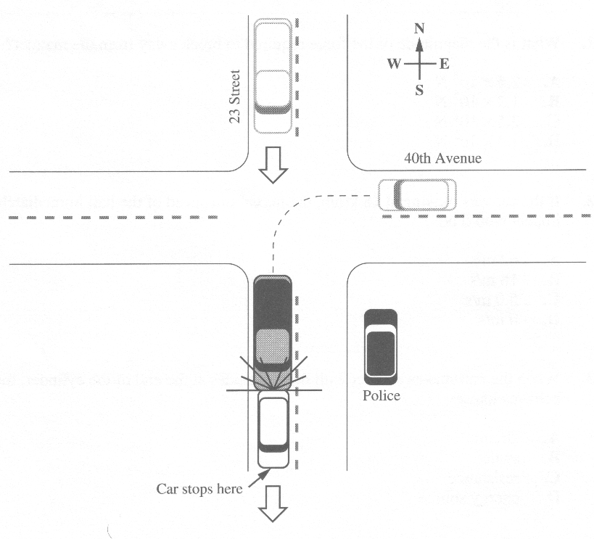
A police officer is parked on the southeast comer of 23 St. and 40 Ave. looking for speeding drivers. She is using a radar gun.

At the same comer, a westbound car turns south and then comes to a stop. A southbound truck crashes into the rear end of the stopped car. The two vehicles lock together and continue moving south.

Numerical Response

- If the radar gun uses EMR that has a period of 4.20 x 10⁻¹⁰ s, the wavelength of the emitted wave is b x 10^{-w} m. The value of b is ________.

(Record your three-digit answer in the numerical-response section on the answer sheet.)

- The radar gun uses EMR in the microwave range. This type of EMR is generated by
A. a continuous DC current
B. an oscillating current in a solid-state device
C. a rapid deceleration of high energy electrons
D. an electron making a jump to a higher energy level

- After witnessing the accident, the police officer uses a radio to call an emergency response team. The team is located 18.5 km from the accident when it receives the officer's direct transmission. The time it takes for the signal to travel to the team is
A. 6.17 x 10⁻⁸ s
B. 1.62 x 10⁻⁷ s
C. 6.17 x 10⁻⁵ s
D. 1.62 x 10⁻⁴ s

- The truck is equipped with a driver's-side air bag that was activated during the collision with the car. The main purpose of an air bag system is to
A. shorten the stopping time of the driver's head and upper body as they move forward
B. act as a cushion and shield for glass and flying debris
C. lengthen the stopping time of the driver's head and upper body as they move forward
D. prevent the steering wheel from collapsing

Numerical Response

- The car has a mass of 1850 kg. The truck was travelling at 65.1 km/h just before impact. After the car and truck locked together, they travelled at 26.2 km/h. The mass of the truck, expressed in scientific notation, is b x 10^{w} kg. The value of b is ________.

(Record your three-digit answer in the numerical-response section on the answer sheet.)

Use the following information to answer the next three questions.
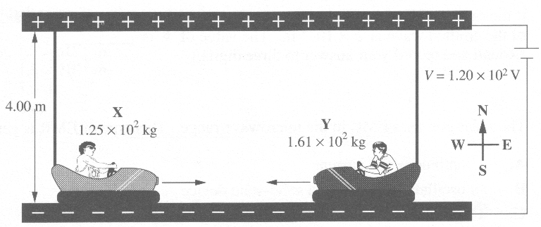
Bumper cars operate on electricity. The more the accelerator pedal is pressed, the more current flows in the system, thus the faster the car travels. Car X and car Y are going to collide head-on. Car X is travelling at a constant velocity of 2.25 m/s to the east and car Y is travelling at a constant velocity of 1.30 m/s to the west.

Numerical Response

- The total mechanical energy of the bumper cars described, expressed in scientific notation, is b x 10^{w} J. The value of b is _________.

(Record your three-digit answer in the numerical-response section on the answer sheet.)

- If after the collision car Y is travelling at 0.526 m/s to the east, the velocity of car X immediately after impact would be
A. 1.02 x 10⁻¹ m/s to the west
B. 3.25 m/s to the east
C. 4.60 m/s to the east
D. 1.02 x 10¹ m/s to the west

- The electric field between the top and bottom grids of the system is
A. 30.0 N/C up
B. 30.0 N/C down
C. 480 N/C up
D. 480 N/C down

Use the following information to answer the next two questions.

A stationary bomb exploded in a street in the centre of a city. The three pieces of debris from the bomb, each of approximately the same mass, flew off horizontally in different directions. Analysis revealed that one piece moved east at 20.0 m/s, and a second piece moved southeast at 30.0 m/s.

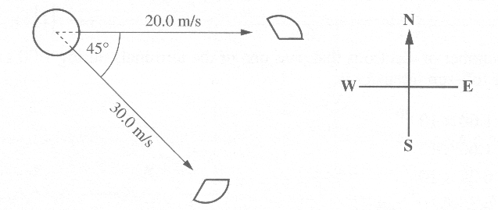

- The third piece of debris was difficult to locate. Where should investigators look for the third piece?
A. 27º W of N
B. 27º N of W
C. 22.5º S of W
D. 22.5º N of E

Numerical Response

- The speed of the third piece, expressed in scientific notation, is b x 10^{w} m/s. The value of b is ________.

(Record your three-digit answer in the numerical-response section on the answer sheet.)

Use the following information to answer the next four questions.

A solar-powered battery maintainer is used to recharge batteries in automobiles. The maintainer uses a solar cell consisting of several cells in series. The solar cell has dimensions of 35.0 cm x 12.0 cm. It produces 1.00 x 10² mA of current at 14.5 V under full-sun intensity.

- The number of electrons that pass one of the terminals during 1.00 s at 14.5 V under full-sun intensity is
A. 1.60 x 10⁻²⁰
B. 1.60 x 10⁻¹⁷
C. 6.25 x 10¹⁷
D. 6.25 x 10²⁰

- Increasing the area of the solar cell to 630 cm² would
A. have no significant effect
B. decrease the current
C. increase the current
D. decrease the potential difference

- To recharge a battery, electrons must be replaced. A typical automotive headlight operates with 1.0 A of current at 12 V. If the headlight is left burning for 1.0 h, what is the time required for the battery maintainer to replace the same number of electrons?
A. 8.3 x 10⁻¹ h
B. 1.0 x 10¹ h
C. 1.0 x 10² h
D. 1.0 x 10³ h

Numerical Response

- The average amount of energy being given to each electron by the solar cell, expressed in scientific notation, is b x 10^{-w} J. The value of b is ________.

(Record your three-digit answer in the numerical-response section on the answer sheet.)

I
- A student wishes to verify that 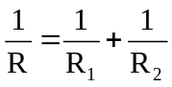 for resistors in parallel. He has two known resistors, R₁ and R₂ , a power source, an ammeter, and a voltmeter. Which circuit should he set up?
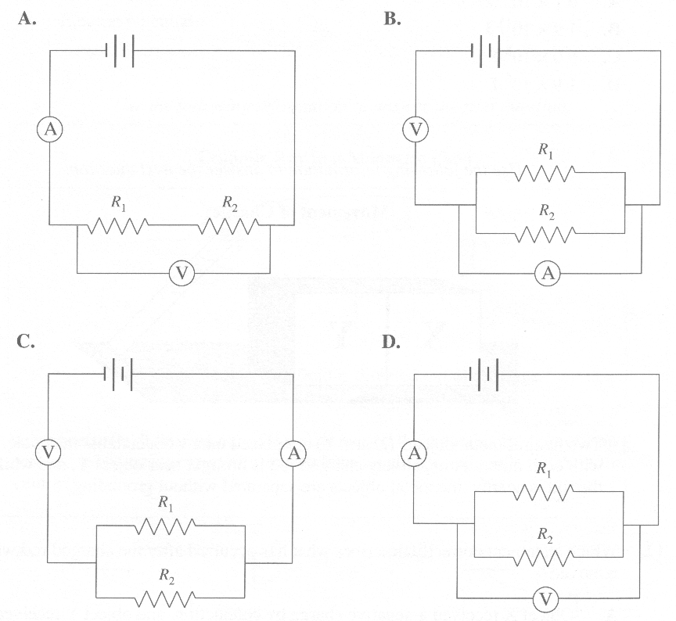

- Lightning maintains the potential difference between the surface of Earth and the ionosphere. In a typical lightning strike, 20 C of charge is transferred from the surface of Earth to a cloud through a potential difference of 3.0 x 10⁷ V in 3.10 x 10⁻³ s. The electrical energy released in the lightning discharge is
A. 6.1 x 10¹³ J
B. 1.9 x 10¹¹ J
C. 6.0 x 10⁸ J
D. 1.9 x 10⁶ J

Use the following information to answer the next question.

Movement of Charges
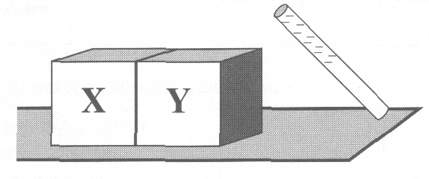
Two neutral metal objects (X and Y) are placed on a wooden table in contact with each other. A negatively charged rod is brought near object Y, and while the rod is nearby, the metal objects are separated without grounding.

- Which statement correctly describes what has occurred after the charged rod was removed?
A. Object X received a negative charge by conduction, and object Y received a positive charge by conduction
B. Object X received a negative charge by induction, and object Y received a positive charge by induction
C. Objects X and Y both received a negative charge by induction
D. Objects X and Y both received a negative charge by conduction

- Which of the following quantities must be represented as scalar?
A. Velocity
B. Magnetic force
C. Acceleration
D. Electric potential

Use the following information to answer the next question.

Cathode Ray in a Magnetic Field
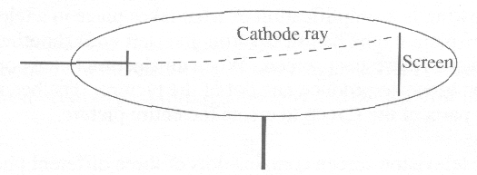

An external magnetic field is directed out of the page.

- A magnetic field directed out of the page caused the cathode rays to move up the screen. What arrangement of electric plates would cause them to return to the centre?
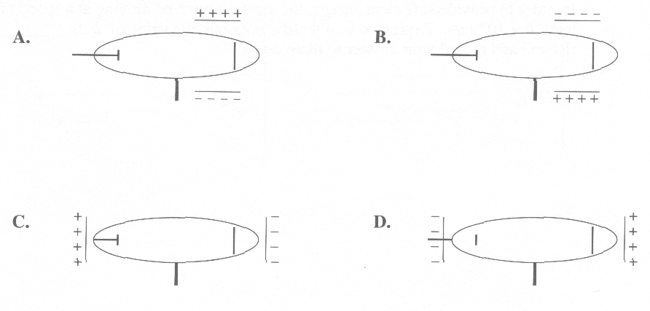

Use the following information to answer the next three questions.

Television Picture Tube
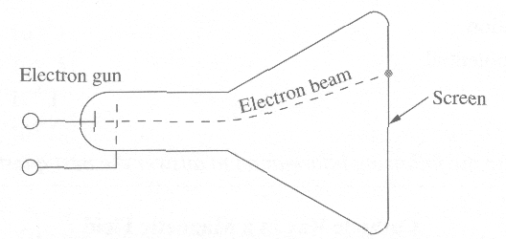
The following is a simplification of what takes place in a television picture tube. The picture tube has an electron gun (left end) shooting a beam of electrons at a fluorescent screen. When an electron beam contacts the screen, the screen glows to produce one dot of the picture. The beam is directed at different parts of the screen to create the entire picture.

A colour television screen contains dots of three different phosphorescent materials that glow red, green, or blue.

Numerical Response

- An electron from the beam hits an atom of the phosphor, causing it to make a transition to a higher energy level. A short time later, the atom makes a transition to the original state, releasing a photon of red light with wavelength 7.02 x 10⁻⁷ m. In order to provide sufficient energy, the electron must be moving at a speed of at least b x 10^{w} m/s. Expressed in scientific notation, the value of b is _________.

(Record your three-digit answer in the numerical-response section on the answer sheet.)

Use your recorded answer from Numerical Response 6 to answer Numerical Response 7.

Numerical Response

- The voltage that would be required to accelerate the electron to the speed recorded in Numerical Response 6, expressed in scientific notation, is b x 10^{w} V. The value of b is

(Record your three-digit answer in the numerical-response section on the answer sheet.)

- Assume that  represents B out of the page and  represents B into the page. The electrical polarity of the electron gun and magnetic field orientation that will cause the electron beam to pass through the tube and deflect upward is shown in
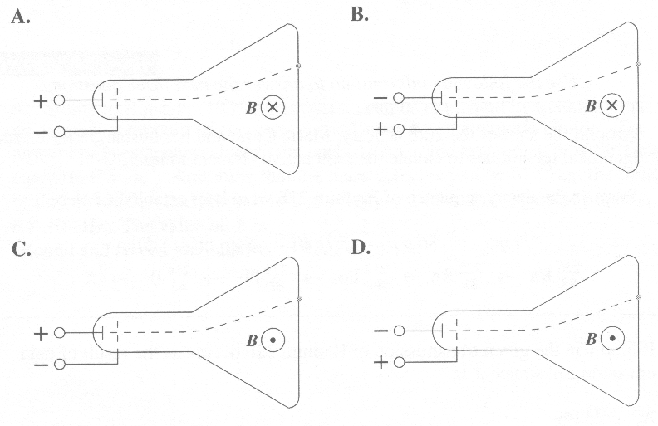

- Three common types of radiation occur during natural decay: alpha, beta, and gamma. Descriptions of alpha, beta, and gamma radiation, respectively, are
A. electromagnetic radiation, He²⁺ , electrons
B. electrons, electromagnetic radiation, He²⁺
C. He²⁺, electrons, electromagnetic radiation
D. He²⁺, electromagnetic radiation, electrons

- Some forms of radiation beams can be bent by passing them through an electric or magnetic field. This could be a useful process for focusing radioactive emissions. This method could be applied to
A. alpha and beta radiation
B. alpha and gamma radiation
C. beta and gamma radiation
D. alpha, beta, and gamma radiation

Use the following information to answer the next three questions.

Around the start of the 20th century, Marie Curie and her husband Pierre used chemical techniques to isolate the radioactive element radium.

Steps in the decay sequence of Radium 226 were later established to be
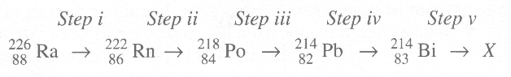

- If Step v in the given transmission of Radium 226 occurs as the result of beta emission, substance X is
A. 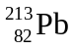
B. 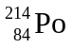
C. 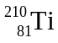
D. 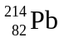

- The half-life of Radon 222 is 3.82 days. Given a 35.0 g sample, how many days will it take for the mass of the radon to be reduced to 2.19 g?
A. 0.417 days
B. 8.37 days
C. 15.3 days
D. 16.0 days

- Which other step is accomplished by beta emission?
A. Step i
B. Step ii
C. Step iii
D. Step iv

Numerical Response

- According to Einstein (1905), mass defect can be explained by assuming that an equivalent amount of energy is carried away by an energetic photon. The amount of energy equivalent to the mass defect could be predicted by the famous equation E = mc². Assuming that the mass defect is 9.00 x 10⁻³⁰ kg, the frequency of the photon that corresponds to that energy, expressed in scientific notation, is b x 10^{w} Hz. The value of b is __________.

(Record your three-digit answer in the numerical-response section on the answer sheet.)

Use the following information to answer the next two questions.

Food preservation is an ongoing human concern. A new technology, food irradiation, preserves food by destroying parasites and micro-organisms, and inhibiting sprouting. This is accomplished by passing the food through a thick-walled chamber containing a source of radiation such as Cobalt-60 that produces gamma rays. The half-life of Cobalt-60 is 5.3 years.

- In 1994, a new Cobalt-60 unit could irradiate 10 000 kg of potatoes per day. By the year 2010, the rate of flow of potatoes through this unit should be reduced to about
A. 5000 kg per day
B. 2500 kg per day
C. 1200 kg per day
D. 600 kg per day

Use the following additional information to answer the next question.

Excerpt from the Periodic Table
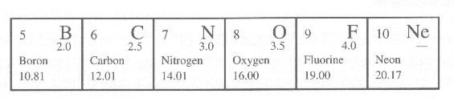

- If alpha radiation were used instead of gamma radiation, there might be a problem with transmutation of elements in the food. Which of the following transmutations produces alpha radiation?
A. Oxygen to fluorine
B. Oxygen to neon
C. Carbon-12 to radioactive Carbon-14
D. Carbon to nitrogen

- A fluorescent light tube contains a gas mixture at low pressure. When a current is passed through the tube, it gives off light energy because the
A. electron orbitals of the gas atoms decay according to Maxwell's Laws
B. electrons of the gas atoms are initially excited to higher energy levels
C. electrical energy transforms to vibrational energy in the atomic band
D. electrical current is scattered by the nuclei of the gas atoms

Use the following information to answer the next four questions.

Following the introduction of quantum theory in the early 1900s, the centuries-old arguments concerning the wave or particle nature of light and other electromagnetic radiation were reinvestigated. The diagrams below depict experiments performed to demonstrate the particle properties of electromagnetic waves.

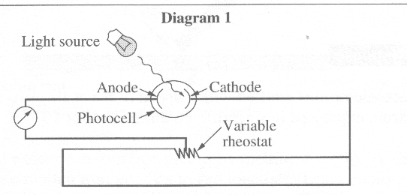
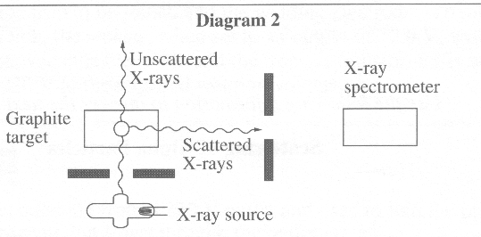

- The two experiments depicted successfully proved that EM wave photons are similar to particles in that they both have
A. wavelength and momentum
B. energy and momentum
C. energy and wavelength
D. energy and frequency

- The experiments depicted in the diagrams were used to prove theories concerning particle properties of EM waves described by
A. Einstein and Compton
B. Einstein and de Broglie
C. Einstein and Rutherford
D. Compton and de Broglie

- Louis de Broglie proposed a hypothesis that was related to which of the following statements?
A. The energy absorbed by an atom is the same as the energy released by the atom.
B. If light has particle properties, then particles may have wave properties.
C. The intensity of light controls the current in the photoelectric effect.
D. Energy and mass are related.

Numerical Response

- If the photoelectron is emitted with a speed of 6.8 x 10⁵ m/s, the kinetic energy of the electron, expressed in scientific notation, is a.b x 10^{-cd} J.
The values of a, b, c, and d are _____, _____, _____, and _____ .

(Record all four digits in the numerical-response section on the answer sheet.)

Use the following information to answer the next question.

Scattering of Alpha Particles

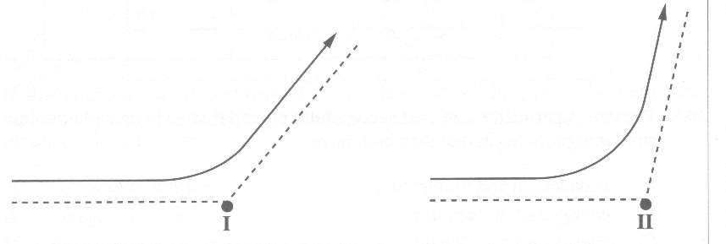
These diagrams show the paths of two alpha particles of the same energy that are scattered by the nuclei of two different types of atoms.

- Which statement correctly explains the difference in the deflection of the alpha particle?
A. The size of nucleus II is greater than the size of nucleus I.
B. The mass of nucleus II is greater than the mass of nucleus I.
C. The charge on nucleus II is greater than the charge on nucleus I.
D. The charge on the particle scattered by nucleus II is greater than the charge on the particle scattered by nucleus I.

Use the following information to answer the next two questions.

Electrical Welding
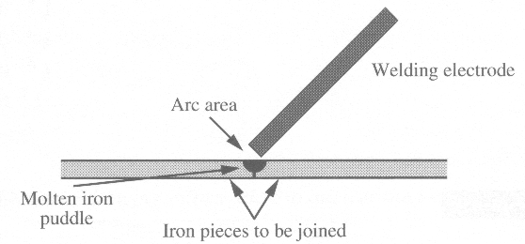
An electric-arc welder can join iron pieces by melting a section of each piece and allowing the molten iron puddles to run together. Upon cooling, one piece is formed. The heat required is produced by an electrical discharge (the arc) between the iron to be joined and the welding electrode. To join pieces of iron 0.30 cm thick, the welder, when set to an output of 32.0 V, will send 100 A of current between the electrode and the iron. A transformer is used to convert from 220 V to the required welding voltage.

Numerical Response

- The arc welder is operated from a 220 V outlet and used to join the pieces of iron. The amount of current that flows through the outlet is __________ A.

(Record your three-digit answer in the numerical-response section on the answer sheet.)

- If the energy supplied to the arc welder is supplied from a wall outlet at home, the welder requires a second transformer to convert from 110 V to an operating voltage of 220 V. Several procedures are described below.
I. Double the number of turns on the primary coil of the second transformer
II. Half the number of turns on the primary coil of the second transformer
III. Double the number of turns on the secondary coil of the second transformer
IV. Half the number of turns on the secondary coil of the second transformer

Which of these procedures would produce the desired result?
A. I or III
B. I or IV
C. II or III
D. II or IV

- A group of hydrogen atoms are in the excited n = 4 state. As they drop to the ground state, the maximum number of different wavelengths of photons that could be emitted is
A. 1
B. 2
C. 4
D. 6

Numerical Response

- The energy of an electron in the third energy level of hydrogen is – __________ eV.

(Record your three-digit answer in the numerical-response section on the answer sheet.)

Use the following information to answer the next two questions.

An electron drops from the third energy level to the second energy level of an excited hydrogen atom.

- The wavelength of the photon emitted is
A. 5.45 x 10⁻⁷ m
B. 6.55 x 10⁻⁷ m
C. 1.53 x 10⁶ m
D. 1.83 x 10⁶ m

Numerical Response

- The energy of the emitted photon, expressed in scientific notation, is b x 10^{-w} J. The value of b is _______.

(Record your three-digit answer in the numerical-response section on the answer sheet.)

- When a certain material is irradiated with ultraviolet light of wavelength 4.0 x 10⁻⁸ m, it releases photoelectrons having a maximum kinetic energy of 30.0 eV. The work function of the material is
A. 1.7 x 10⁻¹⁹ J
B. 4.8 x 10⁻¹⁸ J
C. 5.0 x 10⁻¹⁸ J
D. 4.0 x 10⁻⁹ J

Use the following information to answer the next question.
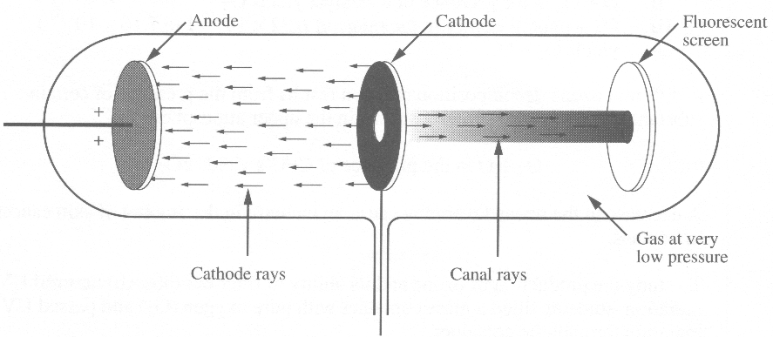
In 1886, Eugene Goldstein discovered a new type of ray that he called canal rays, because they travelled in straight lines opposite to the direction of cathode rays and appeared to emerge from a hole or canal in the cathode.

- By placing either a magnetic or electric field between the cathode and the screen, the canal rays can be bent. This would indicate they are
A. charged particles
B. mechanical waves
C. uncharged particles
D. electromagnetic waves

